17th SUNDAY IN ORDINARY TIME
Three parables: the treasure, the pearl and the net.

First Reading: 1 Kings 3:5, 7-12
At Gibeon the Lord appeared to Solomon in a dream by night; and God said, “Ask what I should give you.” And Solomon said, “You have shown great and steadfast love to your servant my father David, because he walked before you in faithfulness, in righteousness, and in uprightness of heart toward you; and you have kept for him this great and steadfast love, and have given him a son to sit on his throne today. And now, O Lord my God, you have made your servant king in place of my father David, although I am only a little child; I do not know how to go out or come in. And your servant is in the midst of the people whom you have chosen, a great people, so numerous they cannot be numbered or counted. Give your servant therefore an understanding mind to govern your people, able to discern between good and evil; for who can govern this your great people?” It pleased the Lord that Solomon had asked this. God said to him, “Because you have asked this, and have not asked for yourself long life or riches, or for the life of your enemies, but have asked for yourself understanding to discern what is right, I now do according to your word. Indeed I give you a wise and discerning mind; no one like you has been before you and no one like you shall arise after you.

Responsorial: Psalm 118:57, 72, 76-77, 127-130
Response: Lord, how I love your commands
My part, I have resolved, O Lord,
is to obey your word.
The law from your mouth means more to me
than silver and gold. Resp:
Let your love be ready to console me
by your promise to your servant.
Let your love come to me and I shall live
for your law is my delight. Resp:
That is why I love your commands
more than finest gold.
That is why I rule my life by your precepts:
I hate false ways. Resp:
Your will is wonderful indeed;
therefore I obey it.
The unfolding of your word gives light
and teaches the simple. Resp:

Second Reading: Romans 8:28-30
We know that all things work together for good for those who love God, who are called according to his purpose. For those whom he foreknew he also predestined to be conformed to the image of his Son, so that he might be the firstborn within a large family. And those whom he predestined he also called; and those whom he called he also justified; and those whom he justified he also glorified.

Gospel Acclamation:
Alleluia, Alleluia !
Blessed are you, Father, Lord of heaven and earth,
You have revealed to little ones the mysteries of the kingdom.
Alleluia !

Gospel: Matthew 13:44-52
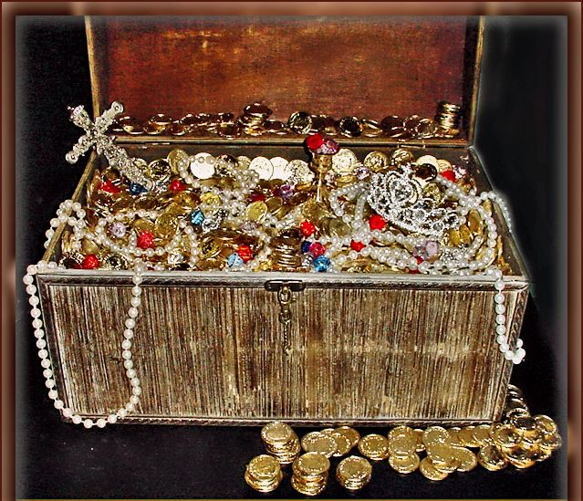

The treasure, the pearl and the net.
“The kingdom of heaven is like treasure hidden in a field, which someone found and hid; then in his joy he goes and sells all that he has and buys that field. Again, the kingdom of heaven is like a merchant in search of fine pearls; on finding one pearl of great price, he went and sold all that he had and bought it.
“Again, the kingdom of heaven is like a net that was thrown into the sea and caught fish of every kind; when it was full, they drew it ashore, sat down, and put the good into baskets but threw out the bad. So it will be at the end of the age. The angels will come out and separate the evil from the righteous and throw them into the furnace of fire, where there will be weeping and gnashing of teeth. “Have you understood all this?” They answered, “Yes.” And he said to them, “Therefore every scribe who has been trained for the kingdom of heaven is like the master of a household who brings out of his treasure what is new and what is old.”

REFLECTIONS
Those of us reared in the country are familiar with how fiercely an old farmer can cling on to his land. Even a miserable patch of grassy bog feels like an insurance against abandonment. But hanging on is not the answer. It only sows bitterness and frustration in sons whose best years are squandered in waiting. Sons who in turn never learn themselves from the mistakes of their fathers. Love alone can guarantee security and care in one’s declining years. Possessions provide only the illusion of security.
Elderly farmers are not the only ones who hold on to things for security. Others have their own holdings from which only death can separate them. It may be property and wealth, status and prestige or power and influence. It may even be an awful lot less, trivial comforts and an easy life. It may be a sixteen-hour day or the thankless responsibility of high office. Or a reputation we can no longer live up to. There is nothing more pathetic than an ageing beauty queen who refuses to accept the ravages of time.
“Ask what you would like me to give you,” God said to Solomon. “Give your servant a heart to understand how to discern between good and evil,” he replied. It is the kind of gift we all need. Possessions come in many forms. It is not so much these possessions that we should rid ourselves of, as the demon of possession itself that should be exorcised. Poverty has become a dirty word in the world we live in. We should not let an Ethiopian famine or a Rwanda disaster make us forget that poverty is also a Christian virtue. It is no accident that Christ began his Sermon on the Mount with “Blessed are the poor in spirit, for theirs is the kingdom of heaven.” Or that the only condition for his followers is that “they leave all things.” Or that the rich young man should have failed all because he failed this one test, “for he had great possessions.” Or that the pearl in today’s parable could only be bought by “selling everything he owns.”
The trouble with most people is that they want it both ways. All this and the good life too. But they can’t have it both ways.
There is a pearl for everyone. And there is a price for everyone to pay. A price tailored to each individual circumstances. Detachment is that price. To be able to walk away from what we cherish most without so much as looking back with regret. Our tragedy is not that we cannot find the pearl but that we are unwilling to pay the price.

